Supplemental Educational Services
in Sample City, KS for 2008-09: An Evaluation of Results

Dan Wright

During the 2008-09 school year, Supplementary Educational Services (SES) provided tutoring services in reading and math to over 1,200 students, grades K-8, in the Sample City, KS school district. These services were available to students who received free or reduced lunch in any of the fourteen district schools on Title I Improvement that year. Seven independent providers, selected by parents at the beginning of the school year, delivered an average of about 25 hours of tutoring per student in either reading or math (or in both subjects) at a specified hourly rate; altogether, over $1,000,000 in Title I funds were expended.
Evaluation Plan
The approach chosen for evaluation of implementation was a matched-groups study, comparing the progress of SES recipients with closely matched students who did not receive tutoring. The challenge to this approach is the availability of enough nonparticipating students, matched on relevant characteristics, to sustain analyses. Selection of students for the study was structured by the following considerations:
- SES recipients and nonparticipating students, alike, were included in analyses only if they attended a single Sample City school for the entire 2008-09 school year. This eliminated the confounding effect of receiving instruction at multiple schools.
- SES recipients were included only if they received tutoring from a single provider during the school year.
- All nonrecipients received free or reduced school lunch in Title I schools and were also, therefore, eligible for SES tutoring.
- Matched nonparticipants were selected, one-for-one, from the same classrooms as SES recipients at the elementary level, or from the same team of teachers at middle school. In addition to ensuring grade-level matches, this controlled for teacher proficiency and for the instructional climates of different schools.
- Students were matched, one-for-one, on Special Education and ELL status (received services or not).
- Students were matched by performance level on the Kansas Assessments or on the Measures of Academic Progress (MAP) at the outset.

Outcomes on Reading Measures
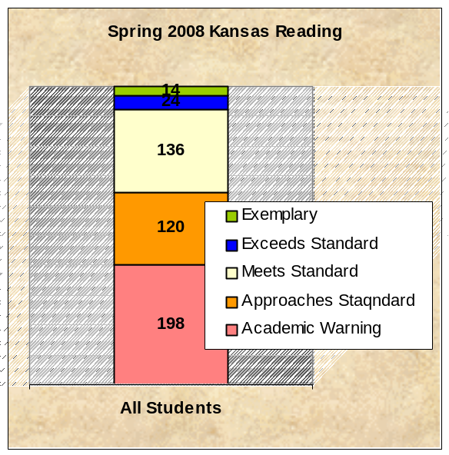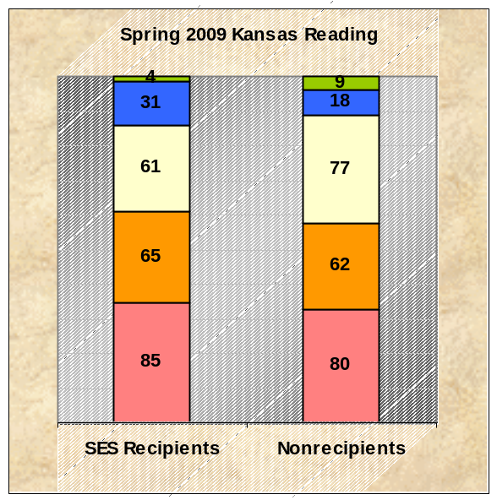
A total of 246 SES students were successfully matched with nonparticipants on both the 2008 Kansas Reading Assessment (grades 3-7) and 2009 Kansas Reading (grades 4-8). Distributions on the performance levels of that measure are presented above. Small improvement was noted for both groups, although comparison of the two distributions on the 2009 assessment, using the Mann-Whitney U test, indicated no significant difference (p = .693).

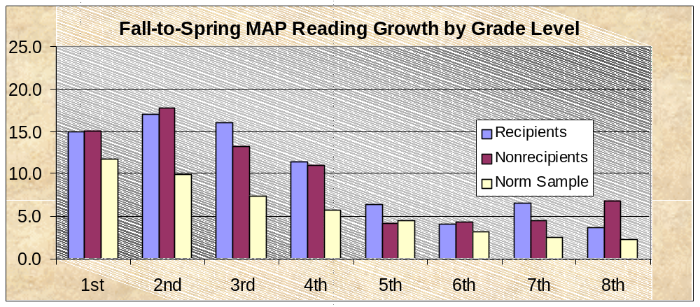
A total of 309 SES students were successfully matched with nonparticipants on both the fall and spring administrations of MAP Reading at grades 1-8. Spring results, in RIT score points, were examined for both groups via Analysis of Covariance (ANCOVA), using fall scores as the covariate. The difference was found to be nonsignificant (F = .152, p = .697). Fall-to-spring gains are presented above, by grade level, for easier review.
Outcomes on Math Measures
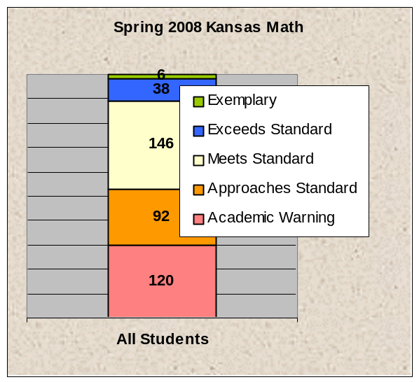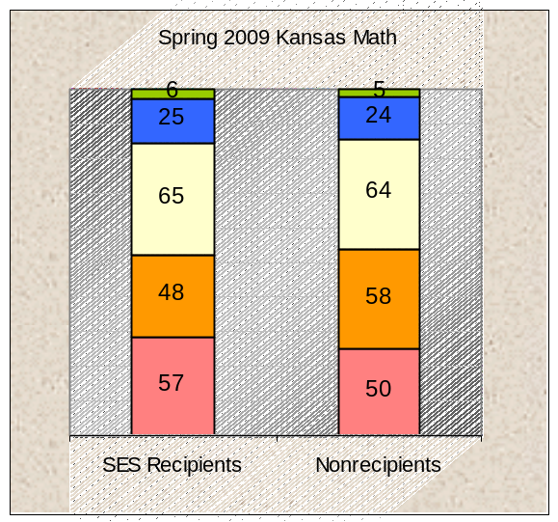
A total of 201 SES students were successfully matched with nonparticipants on both the 2008 Kansas Math Assessment (grades 3-7) and 2009 Kansas Math (grades 4-8). Distributions on the performance levels of that measure are presented above. Comparison of the distributions of the two student groups on the 2009 assessment, using the Mann-Whitney U test, indicated no significant difference (p = .934).
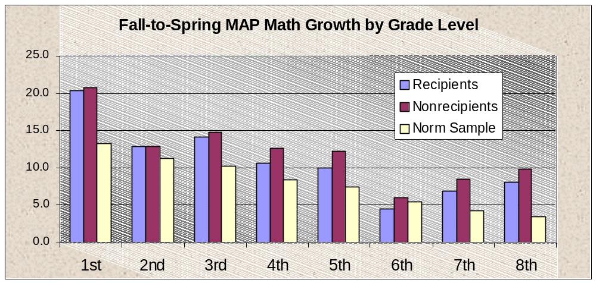
A total of 271 SES students were successfully matched with nonparticipants on both the fall and spring administrations of MAP Reading at grades 1-8. Spring results, in RIT score points, were examined for both groups via Analysis of Covariance (ANCOVA), using fall scores as the covariate. The difference was found to be nonsignificant (F = 2.76, p = .097). Although this result approached statistical significance (if p < .05), it should be noted that the stronger performance was evident among the nonrecipients. Fall-to-spring gains are presented above, by grade level, for easier review.

Summary of Outcomes Analyses
Analyses with all measures revealed no significant differences between outcomes for the SES recipients and the nonparticipants. Progress for both groups of students was observed on MAP measures of Reading and Math, while progress on the Kansas Assessments was only evident in Math. This may indicate the Kansas measures are less sensitive to change, since the five categories that comprise the performance distributions are much broader than the RIT scale employed by the MAP.
The hours of services provided to individual students varied considerably, from only one or two hours for a few students who withdrew quickly to nearly 60 hours for a few others. Mean hours of service were 26.4 for reading and 25.6 for math. Although some linear relationship would be assumed between hours of tutoring and achievement gains, these correlations were in fact very low; for MAP Reading, r = .21 (p = .000), and for MAP Math, r = .18 (p = .000). In hopes that a threshold of effect might be detected, all the above analyses were repeated with subsets of students who had received at least 25 hours of tutoring (and their matched counterparts). In the interest of brevity, a second set of results will not be presented here. However, despite still-adequate sample sizes, no significant group differences were noted.
This leaves us with the perplexing result that absolutely no impact was observed for SES services in either reading or math, on summative measures used for accountability and district planning, when compared with students who were carefully matched on important characteristics but who did not receive these services.
Survey Responses from Stakeholders
Surveys regarding the implementation of tutoring services and satisfaction with progress were collected from 710 of the 1,214 students who participated, as well as from 317 parents and 98 teachers (many of whom dealt with multiple providers). The vast majority of students, as well as parents, indicated they found the tutoring services to be moderately to very helpful, although neither group had a basis for comparison on which to judge relative progress.
Teachers, however, were asked about their relationship with the SES providers and the amount of communication that passed between them. Those responses are suggestive.

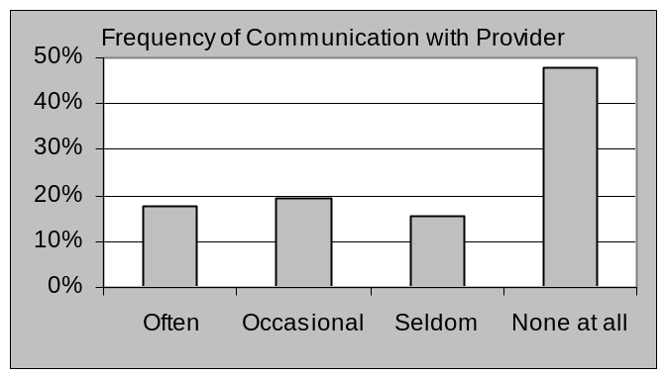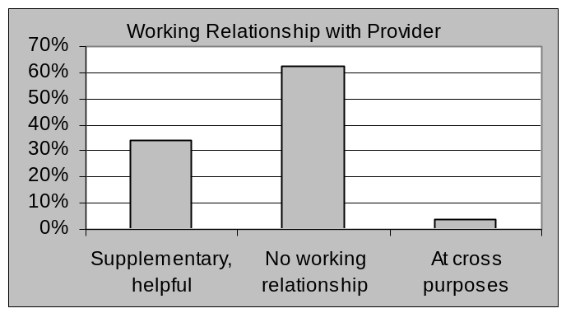
In summary, about two-thirds of the regular classroom teachers of SES recipients indicated they had little or no communication with the SES providers that worked with their students. Additionally, about two-thirds of these teachers indicated they had virtually no working relationship with the providers. The picture that emerges is one of largely disconnected, external services that are not integrated with, or informed by, the instructional life of the students’ classrooms.
Discussion
SES providers are required to monitor student progress and report periodically to parents and to the state department of education. Their measures of progress tend to be pre- and post-tests, closely aligned with instructional modules so as to be sensitive to intervention, and useful for informing self-contained programming. Close communication with the schools, however, would add another dimension of planning and accountability that is not currently mandated. A director of one SES provider, upon reviewing an earlier draft of this report, conveyed the following concerns via personal e-mail:
“There is no mechanism or process to effectively work with Principals and Classroom teachers. Principals and Classroom teachers are not compelled to communicate due to a number of factors, the least of which is not having the time required to add that additional contact to their already busy schedules. Providers are focused on meeting the requirements of their programs as approved by KSDE and the contracts from the District.”

The implications of this arrangement, in conjunction with results of the analyses, extend both to practice and to the policies by which SES tutoring is mandated. SES providers and the schools with which they ostensibly partner have been given entirely separate reporting and accountability requirements. In addition, no mechanism by which their efforts might be coordinated has been outlined or required. Meaningful integration of external and school instructional efforts, which might be expected to produce a greater impact on achievement, would no doubt be more difficult, time-consuming, and expensive. Yet without the bridge between providers and the schools, SES services seem likely to remain ineffectual.

